1.

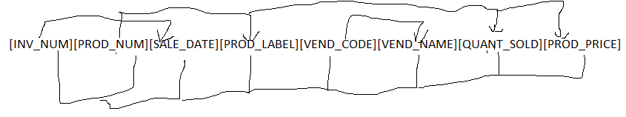
2. Yes. All rows are unique.
3. No. PROD_LABEL and PROD_PRICE are specific to PROD_NUM. A table called PRODUCT should exist with these attributes and PROD_NUM as a PK.
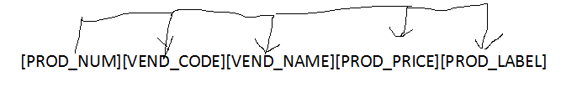
4. No. VEND_NAME is specific to VEND_CODE, and so a VENDOR table should exist with VEND_CODE as a PK.


